Proposed modifications to section 9.3 shown below

9.3 The stratified event scheduler

A compliant SystemVerilog simulator must maintain some form of data structure that allows events to be dynamically scheduled, executed, and removed as the simulator advances through time. The data structure is normally implemented as a time-ordered set of linked lists, which are divided and subdivided in a well defined manner.

The first division is by time. Every event has one and only one simulation execution time, which at any given point during simulation can be the current time or some future time. All scheduled events at a specific time define a time slot. Simulation proceeds by executing and removing all events in the current simulation time slot before moving on to the next nonempty time slot, in time order. This procedure guarantees that the simulator never goes backwards in time.

A time slot is divided into a set of ordered regions:
- Preponed
- Pre-Active
- Active
- Inactive
- Pre-NBA
- NBA
- Post-NBA
- Observed
- Post-Observed
- Reactive
- Re-Inactive
- Pre-Re-NBA
- Re-NBA
- Post-Re-NBA
- Pre-Postponed
- Postponed

The purpose of dividing a time slot into these ordered regions is to provide predictable interactions between the design and testbench code.

The Pre-Active, Active, Inactive, Pre-NBA, NBA, Post-NBA, Pre-Postponed and Postponed regions essentially encompass the IEEE 1364-2005 reference model for simulation, with exactly the same level of determinism. In other words, legacy Verilog code shall continue to run correctly without modification within the new mechanism.

9.3.1 Active region & reactive region sets

There are two important groupings of event regions that are used to help define the scheduling of SystemVerilog activity, they are the active region set and the reactive region set. Events scheduled in the Active, Inactive, Pre-NBA, NBA, and Post-NBA regions are active region set events. Events scheduled in the Reactive, Re-Inactive, Pre-Re-NBA, Re-NBA, and Post-Re-NBA regions are reactive region set events.

The Active, Inactive, Pre-NBA, NBA, Post-NBA, Observed, Post-Observed, Reactive, Re-Inactive, Pre-Re-NBA, Re-NBA, Post-Re-NBA, and Pre-Postponed regions are known as the iterative regions.

In addition to the active region set and reactive region set, all of the event regions of each time slot can be categorized as either simulation regions (see 9.3.2) or PLI regions (see 9.3.3).

9.3.2 Simulation regions

The simulation regions of a time slot are the Active, Inactive, NBA, Observed, Reactive, Re-Inactive, Re-NBA and Postponed regions. The flow of execution of the event regions is specified in Figure 9-1.

9.3.2.1 Preponed events region
The #1step sampling delay provides the ability to sample data immediately before entering the current time slot. #1step sampling is identical to taking the data samples in the Preponed region of the current time slot. Sampling in the Preponed region is equivalent to sampling in the previous Postponed region.

Preponed region PLI events are also scheduled in this region (see 9.3.3.1).

9.3.2.2 Active events region
The Active region holds the current active region set events being evaluated and can be processed in any order.

9.3.2.3 Inactive events region
The Inactive region holds the events to be evaluated after all the Active events are processed.

If events are being executed in the active region set, an explicit #0 delay control requires that the process be suspended and an event scheduled into the Inactive of the current time slot so that the process can be resumed in the next Inactive to Active iteration.

9.3.2.4 NBA events region
The NBA (nonblocking assignment update) region holds the events to be evaluated after all the Inactive events are processed.

If events are being executed in the active region set, a nonblocking assignment creates an event in the NBA region scheduled for the current or a later simulation time.

9.3.2.5 Observed events region
The Observed region is for evaluation of property expressions when they are triggered. Triggering an event that designates the clock of an assertion or clocking block more than once in the same time slot shall be an error. During property evaluation, pass/fail code shall be scheduled in the Reactive region of the current time slot. PLI callbacks are not allowed in the Observed region.

9.3.2.6 Reactive events region
The Reactive region holds the current reactive region set events being evaluated and can be processed in any order.

The code specified by blocking assignments in the program block and the pass/fail code from property expressions are scheduled in the Reactive region. The Reactive region is the reactive region set dual of the Active region (see 9.3.2.1).

9.3.2.7 Re-Inactive events region
The Re-Inactive region holds the events to be evaluated after all the Reactive events are processed.

If events are being executed in the reactive region set, an explicit #0 delay control requires that the process be suspended and an event scheduled into the Re-Inactive region of the current time slot so that the process can be resumed in the next Re-Inactive to Reactive iteration. The Re-Inactive region is the reactive region set dual of the Inactive region (see 9.3.2.2).

9.3.2.8 Re-NBA events region
The Re-NBA region holds the events to be evaluated after all the Re-Inactive events are processed.

If events are being executed in the reactive region set, a nonblocking assignment creates an event in the Re-NBA update region scheduled for the current or a later simulation time. The Re-NBA region is the reactive region set dual of the NBA region (see below).

9.3.2.9 Postponed events region
The Postponed region is where the monitoring of signals, and other similar events, takes place.

No new value changes are allowed to happen in the time slot once the Postponed region
is reached. Within this region, it is illegal to write values to any net or variable or to schedule an event in any previous region within the current time slot.

Postponed region PLI events are also scheduled in this region (see 9.3.3.9).

9.3.3 PLI regions

In addition to the simulation regions, where PLI callbacks can be scheduled, there are additional PLI-specific regions. The PLI regions of a time slot are the Preponed, Pre-Active, Pre-NBA, Post-NBA, Post-Observed, Pre-Re-NBA, Post-Re-NBA and Pre-Postponed regions. The flow of execution of the PLI regions is specified in Figure 9-1.

9.3.3.1 Preponed PLI region
The Preponed region provides for a PLI callback control point that allows PLI application routines to access data at the current time slot before any net or variable has changed state. Within this region, it is illegal to write values to any net or variable or to schedule an event in any other region within the current time slot.

NOTE—The PLI currently does not schedule callbacks in the Preponed region.

9.3.3.2 Pre-Active PLI region
The Pre-Active region provides for a PLI callback control point that allows PLI application routines to read and write values and create events before events in the Active region are evaluated (see 9.4).

9.3.3.3 Pre-NBA PLI region
The Pre-NBA region provides for a PLI callback control point that allows PLI application routines to read and write values and create events before the events in the NBA region are evaluated (see 9.4).

9.3.3.4 Post-NBA PLI region
The Post-NBA region provides for a PLI callback control point that allows PLI application routines to read and write values and create events after the events in the NBA region are evaluated (see 9.4).

9.3.3.5 Post-Observed PLI region
The Post-Observed region provides for a PLI callback control point that allows PLI application routines to read values after properties are evaluated (in Observed or earlier region).

NOTE—The PLI currently does not schedule callbacks in the Post-Observed region.

9.3.3.6 Pre-Re-NBA PLI region
The Pre-Re-NBA region provides for a PLI callback control point that allows PLI application routines to read and write values and create events before the events in the Re-NBA region are evaluated (see 9.4).

9.3.3.7 Post-Re-NBA PLI region
The Post-Re-NBA region provides for a PLI callback control point that allows PLI application routines to read and write values and create events after the events in the Re-NBA region are evaluated (see 9.4).

9.3.3.8 Pre-Postponed PLI region
The Pre-Postponed region provides a PLI callback control point that allows PLI application routines to read and write values and create events after processing all other regions except the Postponed region. The flow of execution of the event regions is specified in Figure 9-1.

9.3.3.9 Postponed PLI region
The Postponed region also provides for a PLI callback control point that allows PLI application routines to be suspended until after all the Active, Inactive, NBA, Observed, Reactive, Re-Inactive, and Re-NBA regions have completed. Within this region, it is illegal to write values to any net or variable or to schedule an event in any other region within the current time slot.

<NEW FIG 9.1>

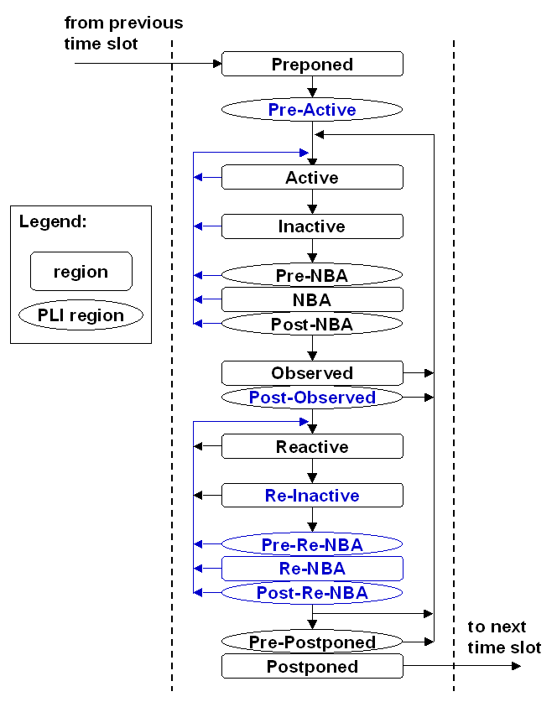

9.3.4 The SystemVerilog simulation reference algorithm

execute_simulation {
T = 0;
initialize the values of all nets and variables;
schedule all initialization events into time 0 slot;
while (some time slot is nonempty) {
move to the next future nonempty time slot and set T;
execute_time_slot (T);
}
}

execute_time_slot {
execute_region (Preponed);
execute_region (Pre-Active);
while (any region in [Active... Pre-Postponed] is nonempty) {
while (any region in [Active... Post-Observed] is nonempty) {
execute_region (Active);
R = first nonempty region in [Active... Post-Observed];
if (R is nonempty)
move events in R to the Active region;
}
while (any region in [Reactive... Post-Re-NBA] is nonempty) {
execute_region (Reactive);
R = first nonempty region in [Reactive... Post-Re-NBA];
if (R is nonempty)
move events in R to the Reactive region;
}
if (all regions in [Active … Post-Re-NBA] are empty)
execute_region (Pre-Postponed);
}
execute_region (Postponed);
}

execute_region {
while (region is nonempty) {
E = any event from region;
remove E from the region;
if (E is an update event) {
update the modified object;
evaluate processes sensitive to the object and possibly schedule
further events for execution;
} else { /* E is an evaluation event */
evaluate the process associated with the event and possibly
schedule further events for execution;
}
}
}

The iterative regions and their order are Active, Inactive, Pre-NBA, NBA, Post-NBA, Observed, Post-Observed, Reactive, Re-Inactive, Pre-Re-NBA, Re-NBA, Post-Re-NBA and Pre-Postponed. As shown in the algorithm, once the Reactive, Re-Inactive, Pre-Re-NBA, Re-NBA or Post-Re-NBA regions are processed, iteration over the other regions does not resume until these five regions are empty.
NOTE TO EDITOR:

The event region names in the SystemVerilog simulation reference algorithm have been modified to meet the standard naming for these event regions in the rest of this section. This serves two purposes: (1) the event region names are more visible in the printed algorithm, and (2) it will make it easier to make the global substitutions required below.

Please make the global event-region replacements in the merged document as follows
(it will be easier for the editor to find all of these occurrences in the document than to list out all of the changes and have the editor check off each change individually - it will also be easier for reviewers to search for the replaced words shown below to verify that all changes have been updated as expected).

(note some of the invalid names may not exist anywhere in the merged document):

WAS: prepone -or- preponed
PROPOSED: Preponed

WAS: Pre-active -or- pre-active
PROPOSED: Pre-Active

(take special care not to globally replace the word active when not used as an event region)
WAS: active
PROPOSED: Active

(take special care not to globally replace the word inactive when not used as an event region)
WAS: inactive
PROPOSED: Inactive

WAS: nba
PROPOSED: NBA

WAS: pre-NBA
PROPOSED: Pre-NBA

WAS: post-NBA
PROPOSED: Post-NBA

WAS: Observed
PROPOSED: Observed

WAS: Post-observed -or- post-observed
PROPOSED: Post-Observed

WAS: Reactive
PROPOSED: Reactive

WAS: Re-inactive -or- re-inactive
PROPOSED: Re-Inactive

(Pre-Re-NBA was just added and should be correctly spelled everywhere)

(Re-NBA was just added and should be correctly spelled everywhere)

(Post-Re-NBA was just added and should be correctly spelled everywhere)

WAS: Pre-postponed -or- pre-postponed
PROPOSED: Pre-Postponed

WAS: Postponed
PROPOSED: Postponed

